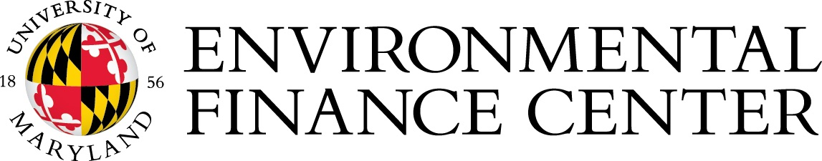

FOR IMMEDIATE RELEASE: October 15, 2018
Contact: Mike Hunninghake, Program Manager, mikeh75@umd.edu, 301-405-7956

Eight municipalities awarded
Sustainable Maryland Certified status for 2018

COLLEGE PARK, Md.—The Environmental Finance Center (EFC) at the University of Maryland announced the eight municipalities that achieved Sustainable Maryland Certified status for 2018. The certifications were bestowed at the Sustainable Maryland Certified awards ceremony during the annual Maryland Municipal League Conference on October 12 in Annapolis, Maryland.

The Sustainable Maryland program provides support and guidance to municipalities looking for cost-effective and strategic ways to protect their natural assets and revitalize their communities. Using best practices in resource areas like water, energy, planning, health, food, and economy, a municipality earns points toward sustainability certification. Currently, 72 of the state’s 157 incorporated municipalities have registered with the program to seek this award designation, with 35 achieving certification as of this year.

According to Mike Hunninghake, Program Manager for Sustainable Maryland, “This year’s class of Sustainable Maryland Certified communities represents significant continued progress on sustainability issues, in small towns and large cities, from all across the state. The Green Teams, elected officials, and municipal staff that have accomplished so much provide both inspiration and real-world examples for their peers to follow.”

The newly certified (denoted by *) and re-certified communities are listed below, followed by a notable achievement from their local sustainability efforts:

Town of Berlin (Worcester County; the very first municipality to be certified in the program in 2012, re-certified in 2015)
Town of Chestertown (Kent County; first certified in 2012, re-certified in 2015)
*Town of Cottage City (NEW!)
Town of Emmitsburg (Frederick County; first certified in 2015)
City of Laurel (Prince George’s County; first certified in 2015)
City of Mount Rainer (Prince George’s County; first certified in 2012, re-certified in 2015)
Town of Poolesville (Montgomery County; first certified in 2015)
City of Rockville (2018 Sustainable Champion; Montgomery County; first certified in 2012, re-certified in 2015)
Our 2018 Sustainability Champion: This year’s Sustainability Champion is the City of Rockville which amassed an impressive 535 points on their application, more than any other community in 2018.
A full report on each certified community’s Actions can be viewed here: http://sustainablemaryland.com/actions-certification/participating-communities/

Sustainable Maryland Certified Municipalities as of 2018 (7th full year of the program):
- Total Municipalities Sustainable Maryland Certified: 35 (22% of Maryland’s municipalities)
- Total Municipalities Sustainable Maryland Registered: 72 (46% of Maryland’s municipalities)

With the support of the Maryland Municipal League and US Environmental Protection Agency, Sustainable Maryland is a free and voluntary program that helps communities choose a direction for their greening efforts; complete their chosen actions with help from program tools, trainings, expert guidance, and other resources; and get recognized statewide for their accomplishments. For more information about Sustainable Maryland, please visit www.sustainablemaryland.com.

The Environmental Finance Center at the University of Maryland works to equip communities with the knowledge, resources and leadership needed to empower decision-making that advances resource management priorities in an innovative and efficient way. Through direct technical assistance, capacity building and program and policy analysis, it strives to move communities towards a more sustainable and resilient future. For more information about the Environmental Finance Center at the University of Maryland, please visit www.efc.umd.edu.
# # #

Photo of the 2018 Sustainable Maryland Certified awardees is below and attached. Photos of each municipality’s Awards Ceremony Attendees, examples of Community Actions, and customized Sustainable Maryland logos are available upon request.

